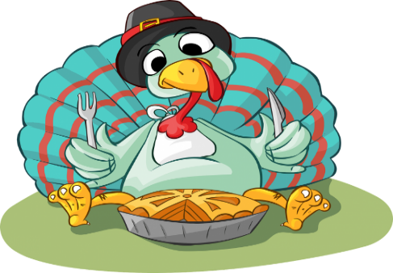
NOVEMBER ACTIVITIES 2023
This Photo by Unknown Author is licensed under CC BY-SA
NATIONAL DIABETES MONTH
SUNDAY | MONDAY | TUESDAY | WEDNESDAY 1 | THURSDAY 2 | FRIDAY 3 | SATURDAY 4
 |  |  | BEAUTY SHOP  9:30 WALMART  1:00 BINGO | MD APPT’S  1:30 GAMES WITH CHRIS & CHARLEY  3:00 CATHOLIC COMM | MANI/PEDI  1:00 BINGO  5:30 MOVIE NIGHT | SCHEDULED WALMART ORDERING WITH CLARK  1:00 BINGO  2:30 DIAMOND ART-JACQUE
5 SCHEDULED WALMART ORDERING WITH CLARK | 6  10:00 BIBLE STUDY-LINDA  1:00 BINGO- CARL & PEGGY | 7  9:30 WALMART  1:00 BINGO  4:30 VETERANS DINNER & PINNING CERAMONY | BEAUTY SHOP 8  1:00 BINGO  2:00 AMVETS PARTY | MD APPT’S 9  1:00 BINGO  3:00 CATHOLIC COMM | MANI/PEDI 10  1:00 BINGO  2:00 HERO’S GALA (party for everyone) | VETERANS DAY 11  SCHEDULED WALMART ORDERING WITH CLARK  10:30 LUNCH OUT-(VETERANS EAT FREE)
12  SCHEDULED WALMART ORDERING WITH CLARK | 13  10:00 BIBLE STUDY – LINDA  1:00 BINGO – CARL & PEGGY | 14  9:30 WALMART  1:00 BINGO  2:00 JEWELRY WITH NINA  WORLD DIABETES DAY | BEAUTY SHOP 15  1:00 BINGO  2:00 PAINTING WITH NANCY | MD APPT’S 16  1:00 BINGO - KASSIDY  2:00 KARAOKE - NINA  3:00 CATHOLIC COMM | MANI/PEDI 17  1:00 BINGO  2:00 WELCOME PARTY  5:30 MOVIE NIGHT | 18  SCHEDULED WALMART ORDERING WITH CLARK  1:00 BINGO
19  SCHEDULED WALMART ORDERING WITH CLARK | 20  10:00 BIBLE STUDY – LINDA  1:00 BINGO | 21  9:30 WALMART  1:00 KAROAKE WITH JULIE & SIBIL  2:00 BINGO | BEAUTY SHOP 22  1:00 BINGO  2:00 JEWELRY WITH NINA | THANKSGIVING 23  12:00 THANKSGIVING DINNER | MANI/PEDI 24  11:30 BIRTHDAY LUNCH  1:30 BIRTHDAY PARTY | 25 SCHEDULED WALMART ORDERING WITH CLARK  1:00 BINGO  2:00 ALABAMA VS AUBURN PARTY
26  SCHEDULED WALMART ORDERING WITH CLARK | 27  10:00 BIBLE STUDY-LINDA  1:00 BINGO  2:00 CHRISTMAS DECORATING BEGINS | 28  9:30 Walmart  1:00 The Village Auction  2:00 JEWELRY WITH NINA | BEAUTY SHOP 29  1:00 BINGO  2:00 EXERCISE WITH MELISSA | MD APPT’S 30  1:30 DIAMOND ART – JACQUE  3:00 CATHOLIC COMM  6:00 JEOPARDY-FBC

